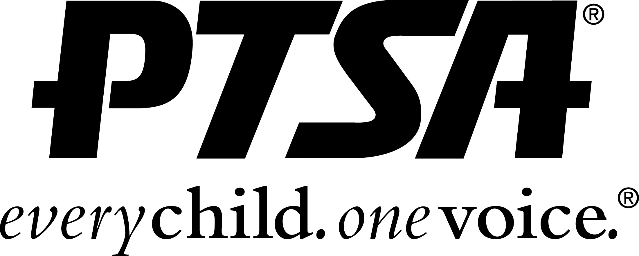
Wake Forest Middle School PTSA
2019-2020 Membership Form
Annual Membership Dues $10.00 per adult / $5.00 per student
Make check payable to: WFMS PTSA. Join online at: wfms.memberhub.store

Member Name: Parent Student

Address:

Cell Phone: Email:

Additional Member Name: Parent Student

Address:

Cell Phone: Email:

FOR PTSA USE ONLY

Payment Method: Square Cash Check # Amount: $

Master List: Memberhub: Certificate: Card/ Email:

Wake Forest Middle School PTSA
2019-2020 Membership Form
Annual Membership Dues $10.00 per adult / $5.00 per student
Make check payable to: WFMS PTSA. Join online at: wfms.memberhub.store

Member Name: Parent Student

Address:

Cell Phone: Email:

Additional Member Name: Parent Student

Address:

Cell Phone: Email:

FOR PTSA USE ONLY

Payment Method: Square Cash Check # Amount: $

Master List: Memberhub: Certificate: Card/ Email:

